22ME411 PRODUCT DEVELOPMENT LAB - 4

AI-DRIVEN CUSTOMER ANALYTICS PLATFORM

A PROJECT REPORT
Submitted by

PARTHASARATHY G | 111723102143
NAVEEN O S | 111723102130
PARANTHAMAN R | 111723102142

in partial fulfillment for the award of the degree of

BACHELOR OF ENGINEERING
IN
COMPUTER SCIENCE AND ENGINEERING

R.M.K. ENGINEERING COLLEGE
(An Autonomous Institution)
R.S.M. Nagar, Kavaraipettai-601 206


March 2025

R.M.K. ENGINEERING COLLEGE

(An Autonomous Institution)
R.S.M. Nagar, Kavaraipettai-601 206

BONAFIDE CERTIFICATE

Certified that this Product Development Lab – 4 report “ AI-DRIVEN CUSTOMER ANALYTICS PLATFORM ” is the bonafide work of PARTHA SARATHY G (111723102143), NAVEEN O S (111723102130), PARANTHAMAN R (111723102142), who carried out the 22ME411 Product Development Lab - 4 work under my supervision.

SIGNATURE

Dr. T. Sethukarasi, M.E., M.S. Ph.D., Professor and Head
Department of Computer Science and Engineering
R.M.K. Engineering College
R.S.M. Nagar, Kavaraipettai
Tiruvallur District– 601206.

SIGNATURE

Ms. Gayathri S, M.E., (Ph.D)., Supervisor
Assistant Professor
Department of Computer Science and Engineering
R.M.K. Engineering College
R.S.M. Nagar, Kavaraipettai Tiruvallur District–601206.

Submitted for the Product Development Lab – 4 Viva –Voce held on………………………

. at R.M.K.Engineering College,
Kavaraipettai, Tiruvallur District– 601206.

INTERNAL EXAMINER

ACKNOWLEDGEMENT

We earnestly portray our sincere gratitude and regard to our beloved Chairman Shri. R. S. Munirathinam, our Vice Chairman, Shri. R. M. Kishore and our Director, Shri. R. Jyothi Naidu, for the interest and affection shown towards us throughout the course.

We convey our sincere thanks to our Principal, Dr. K. A. Mohamed Junaid, for being the source of inspiration in this college.

We reveal our sincere thanks to our Professor and Head of the Department, Computer Science and Engineering, Dr. T. Sethukarasi, for her commendable support and encouragement for the completion of our project.

We would like to express our sincere gratitude for our Product Development Lab Incharge Ms. Gayathri S, Assistant Professor for their valuable suggestions towards the successful completion for this project in a global manner.

We take this opportunity to extend our thanks to all faculty members of the Department of Computer Science and Engineering, Parents and friends for all that they meant to us during the crucial times of the completion of our project.

 | TABLE OF CONTENTS
CHAPTER | TITLE | PAGE NO
 | ABSTRACT | 01
 | LIST OF FIGURES | 02
1 | INTRODUCTION | 03
 | 1.1 Problem Statement | 04
 | 1.2 Project Scope and Objectives | 05
 | 1.3 Literature Survey | 06
 | 1.4 Hardware Requirements | 14
 | 1.5 Software Requirements | 14
2 | SYSTEM ANALYSIS | 15
 | 2.1 Existing System | 15
 | 2.1.1 Disadvantages of Existing System | 16
 | 2.2 Proposed System | 17
 | 2.2.1 Advantages of Proposed System | 18
3 | SYSTEM DESIGN | 20
 | 3.1 System Architecture Diagram | 20
 | 3.2 Use Case Diagram | 23
 | 3.3 Class Diagram | 26
 | 3.4 Data Flow Diagram | 30
 | 3.5 Activity Diagram | 33
4 | SYSTEM IMPLEMENTATION | 37
 | 4.1 List of Modules | 38
 | 4.2 Detailed Module Description | 39
5 | CONCLUSION AND FUTURE SCOPE | 43
 | REFERENCES | 46
 | SCREENSHOTS | 48

ABSTRACT

Small entrepreneurs in the e-commerce sector face challenges in interpreting customer feedback and utilizing data-driven insights for business growth. The increasing volume of online product reviews makes manual sentiment analysis time-consuming, biased, and inefficient. This project introduces an AI-driven Customer Analytics Platform that integrates Natural Language Processing (NLP) for sentiment analysis and Machine Learning (ML) for predictive analytics. The platform classifies customer feedback into positive, neutral, or negative sentiments while identifying key trends that influence customer satisfaction. Additionally, ML-based predictive models analyze historical sales data to forecast demand, optimizing inventory management, pricing, and promotions.
Small businesses often struggle to process and respond to large volumes of customer feedback effectively. Traditional methods fail to detect nuanced sentiments, leading to inaccurate assessments. The lack of automated demand forecasting results in inefficient stock management and missed sales opportunities. This project addresses these issues by leveraging NLP and ML to extract insights, predict trends, and enhance business decision-making.
A core feature of the platform is an interactive dashboard with real-time sentiment tracking and analytics. It provides businesses with key reports on product performance, customer preferences, and sales trends. Automated notifications alert businesses to negative sentiment patterns, high-demand products, and pricing adjustments. By delivering real-time recommendations, the system ensures proactive responses to customer expectations, improving brand reputation and customer retention.
By transforming raw customer feedback into actionable intelligence, this platform empowers small enterprises to enhance operational efficiency, improve customer satisfaction, and drive profitability. In an increasingly data-driven market, this AI-powered solution gives small businesses the competitive edge needed for sustainable growth.

LIST OF FIGURES

Figure No | Name | Page No
3.1 | ARCHITECTURE DIAGRAM | 20
3.2 | USES CASE DIAGRAM | 23
3.3 | CLASS DIAGRAM | 26
3.4 | DATA FLOW DIAGRAM | 30
3.5 | ACTIVITY DIAGRAM | 33

CHAPTER 1 INTRODUCTION

E-commerce has transformed global trade by providing consumers with an easy and convenient way to shop for products. Online platforms have rapidly gained popularity due to their accessibility, product variety, and competitive pricing. However, the vast amount of data generated by customer interactions presents challenges in understanding consumer preferences and sentiments. Customer reviews, a critical aspect of online shopping, influence potential buyers and impact brand reputation. Businesses must efficiently analyze customer feedback to enhance product offerings and service quality.

Manual analysis of customer feedback is impractical due to the sheer volume of reviews. Traditional sentiment analysis methods often focus on binary classification—positive or negative—without delving into “feature-based insights”. This project introduces an “AI-driven Customer Analytics Platform” that leverages “Natural Language Processing (NLP)” and “Machine Learning (ML)” to automatically classify customer sentiment, extract key product-related features, and predict demand trends. By implementing real-time analytics, the system assists businesses in making “data-driven decisions to improve product quality, optimize inventory, and refine pricing strategies”.

The proposed system integrates “aspect-based sentiment analysis (ABSA)” to pinpoint key product attributes influencing customer opinions. It utilizes “keyword extraction methods like YAKE, dependency parsing techniques, and Support Vector Machine (SVM) classification” to categorize sentiments more precisely. Additionally, a “Power BI dashboard” provides interactive visualizations of trends, enabling businesses to track customer sentiment dynamically and adjust strategies accordingly.

This research will not only enhance sentiment analysis by focusing on product-specific features but also introduce predictive analytics for “demand forecasting”, allowing businesses to anticipate market fluctuations and plan inventory effectively. The ultimate goal is to equip small businesses with an “automated, intelligent feedback interpretation system” that streamlines customer interaction analysis, improves operational efficiency, and drives sales growth.

1.1 Problem Statement

The explosion of online shopping has led to an influx of customer reviews and feedback, making it increasingly difficult for businesses to manually track consumer sentiment and product performance. The key challenges businesses face include:

Overwhelming Volume of Reviews: Manually analyzing thousands of reviews across multiple platforms is inefficient and time-consuming.

Lack of Structured Insights: Traditional sentiment analysis often categorizes reviews as positive or negative without extracting specific product-related opinions.

Inaccurate Demand Forecasting: Businesses struggle to predict market trends and adjust inventory levels efficiently, leading to “overstocking or stockouts”.

Limited Actionable Insights: Current systems lack real-time analytics and dynamic reporting, preventing businesses from responding promptly to consumer concerns.

Competitive Pressure: Small and medium-sized enterprises (SMEs) face stiff competition from large-scale e-commerce giants that leverage AI-driven analytics for decision-making.

These challenges necessitate an “automated AI-based system” capable of efficiently extracting, analyzing, and visualizing customer sentiment while providing predictive insights for business strategy optimization.

1.2 Project Scope and Objectives

The proposed AI-driven Customer Analytics Platform aims to address the outlined challenges through the following scope and objectives:

Automated Sentiment Analysis: Implement NLP-driven “feature-based sentiment analysis” to accurately classify customer feedback into “positive, negative, or neutral” categories.

Aspect-Based Opinion Mining: Extract product-specific insights by detecting customer sentiments related to different product features, such as “durability, design, performance, and value for money”.

Predictive Analytics for Demand Forecasting: Utilize ML models to analyze past sales trends and predict future demand, allowing businesses to “optimize inventory management and pricing strategies”.

Integration with Power BI Dashboard: Provide an “interactive, real-time data visualization” tool for businesses to monitor customer sentiment trends and key product issues.

AI-Powered Chatbot Support: Develop an NLP-based chatbot to assist businesses in querying customer reviews and retrieving actionable insights in real time.

Scalability & Deployment: Ensure that the system can handle large datasets efficiently and is “deployed on cloud platforms like AWS or Google Cloud” for scalability.

By integrating these functionalities, the platform will enable businesses to gain “competitive market intelligence, enhance customer satisfaction, and drive profitability through strategic decision-making”.

1.3 Literature Survey

The research draws upon various existing methodologies and studies in the field of sentiment analysis, opinion mining, and predictive analytics. Key areas of literature review include:

Feature-Based Sentiment Analysis: Exploring how sentiment analysis can be enhanced by “focusing on product attributes rather than just overall sentiment polarity”.

Aspect-Based Sentiment Analysis (ABSA): Investigating “dependency parsing and NLP techniques” to accurately extract sentiment tied to specific product features.

Comparison of ML and Lexicon-Based Sentiment Analysis: Evaluating the effectiveness of “machine learning classifiers like SVM, Naïve Bayes, and deep learning models” against traditional lexicon-based approaches.

Keyword Extraction Techniques: Analyzing methods such as “YAKE, TF-IDF, and Latent Dirichlet Allocation (LDA)” for extracting key phrases from product reviews.

Predictive Analytics in E-Commerce: Reviewing studies on “demand forecasting models” powered by AI, such as “time series analysis, regression models, and neural networks”.

Visualization and Business Intelligence Tools: Examining how “Power BI and Google Charts” facilitate interactive data representation for business applications.

[1] S. Rama Krishna, Ketan Rathor, Jarabala Ranga, Anil Kumar N (2023), "Artificial Intelligence Integrated with Big Data Analytics for Enhanced Marketing," IEEE, DOI: 10.1109/ICICT57646.2023.10134043

The integration of artificial intelligence with big data analytics is fundamentally transforming modern marketing strategies by providing businesses with powerful tools to analyze vast consumer data, automate processes, and optimize customer engagement. By leveraging machine learning (ML), deep learning (DL), and natural language processing (NLP), organizations can enhance decision-making, personalize customer experiences, and forecast market trends with greater accuracy. AI-driven marketing enables businesses to refine targeting strategies, increase conversion rates, and maximize return on investment by analyzing user behavior patterns, browsing history, and purchase intent. Real-time insights generated through AI-powered recommendation systems and predictive analytics help companies deliver content and advertisements tailored to individual preferences, fostering stronger customer relationships. Additionally, AI-driven sentiment analysis using NLP enables brands to assess customer emotions, detect emerging trends, and adjust marketing strategies accordingly. However, challenges such as data privacy concerns, ethical considerations, and the need for scalable AI infrastructure pose significant hurdles. Ensuring transparency in AI decision-making processes and implementing robust data governance measures are essential for businesses to fully capitalize on AI's potential in marketing. As AI and big data analytics continue to evolve, their application in marketing will become even more refined, allowing businesses to remain competitive in an increasingly digital landscape​.

[2] Ruturaj Patil, Shivashankar K, Dr. Shantavva M. Porapur, Mr. Shivanand Kagawade (2024), "The Role of AI-Driven Social Media Marketing in Shaping Consumer Purchasing Behaviour," ITM Web of Conferences

The widespread adoption of artificial intelligence in social media marketing has significantly impacted consumer purchasing behavior by enabling businesses to create highly personalized and targeted campaigns. AI-driven predictive analytics, chatbots, and recommendation systems allow brands to engage with potential customers in real-time, influencing their buying decisions more effectively than traditional marketing methods. By analyzing user preferences, browsing history, and interaction patterns through deep learning and NLP-based techniques, AI can optimize advertisement placements, ensuring that consumers receive content most relevant to their interests. Studies indicate that AI-powered targeted ads can improve conversion rates by up to 300%, while predictive analytics enhances marketing effectiveness by up to 20%. The use of AI chatbots, powered by NLP, further strengthens brand-consumer relationships by providing instant support, addressing customer queries, and generating personalized recommendations. However, while AI-driven marketing tools offer significant advantages, issues such as consumer trust, data privacy, and algorithmic transparency remain critical concerns. Many consumers are apprehensive about how AI processes their personal data, leading to increased demand for ethical AI practices and greater transparency in data usage. Future advancements in AI-driven social media marketing must focus on addressing these challenges while continuing to enhance personalization, engagement, and predictive capabilities to drive better business outcomes​.

[3] Lakshmi Nivas Nalla, Vijay Mallik Reddy (2024), "AI-Driven Big Data Analytics for Enhanced Customer Journeys: A New Paradigm in E-Commerce," International Journal of Advanced Engineering Technologies and Innovations

The integration of artificial intelligence with big data analytics is redefining the customer experience in e-commerce by enabling businesses to analyze vast datasets and generate real-time insights that enhance engagement and personalization. AI-driven recommendation engines utilize machine learning, neural networks, and natural language processing (NLP) to predict customer preferences, providing personalized product suggestions that improve conversion rates. Predictive analytics powered by deep learning algorithms helps businesses forecast market demand, optimize inventory management, and streamline supply chain operations, ensuring timely and efficient product deliveries. AI-powered sentiment analysis processes customer reviews and feedback using NLP techniques, allowing companies to gauge customer satisfaction, detect patterns in consumer sentiment, and refine their service strategies. Fraud detection algorithms, utilizing advanced anomaly detection models, strengthen security by identifying unusual transaction patterns and preventing cyber threats. Despite its transformative impact, AI-driven big data analytics presents challenges such as data privacy concerns, regulatory compliance, and the need for scalable infrastructure. Businesses must implement robust security measures and ethical AI frameworks to protect consumer data while leveraging AI to optimize customer experiences. As AI technologies continue to advance, their role in e-commerce will expand further, enabling businesses to anticipate customer needs, enhance operational efficiency, and maintain a competitive edge in the digital marketplace​

[4] Seyyed Hesamoddin Motevalli, Hamidreza Razavi (2024), "Enhancing Customer Experience and Business Intelligence: The Role of AI-Driven Smart CRM in Modern Enterprises," Journal of Business and Future Economy

The rapid evolution of artificial intelligence has transformed customer relationship management by enabling businesses to implement Smart CRM systems that enhance customer engagement, optimize operations, and improve business intelligence. Unlike traditional CRM platforms that rely on manual data entry and static records, AI-driven Smart CRM systems utilize machine learning (ML), predictive analytics, and natural language processing (NLP) to automate processes, deliver personalized customer interactions, and provide real-time insights. These intelligent systems analyze consumer behavior, transaction history, and engagement patterns to offer tailored recommendations and proactive customer support. By employing NLP algorithms, Smart CRMs can analyze unstructured data such as emails, chat logs, and social media interactions to extract meaningful insights, ensuring better customer service and engagement. Through seamless integration with various communication channels, including social media, email, and AI-powered chatbots, Smart CRM platforms ensure a unified and responsive customer experience. The automation of repetitive tasks such as follow-up emails and customer segmentation allows businesses to allocate human resources more efficiently, focusing on strategic decision-making rather than manual data management. However, the implementation of AI-driven Smart CRM systems comes with challenges such as data privacy concerns, ethical implications, and disparities in adoption between small and large enterprises. Companies must strike a balance between AI automation and human-led engagement to maintain customer trust while harnessing AI's capabilities to improve efficiency and customer satisfaction. As Smart CRM technology continues to evolve, its impact on business intelligence and customer relationship management will grow, making it an indispensable tool for organizations looking to enhance their competitive advantage in the digital age​.

[5] Alma Bici, Narasimha Rao Vajjhala (2024), "Emerging Trends and Themes in AI-Driven Customer Engagement and Relationship Management," ICRIEMSD Conference

Artificial intelligence is playing an increasingly critical role in customer engagement and relationship management by enabling businesses to personalize interactions, automate customer support, and gain deeper insights into consumer behavior. AI-powered chatbots and virtual assistants, powered by natural language processing (NLP) and deep learning models, are transforming customer service by providing instant responses, reducing wait times, and improving overall satisfaction. Sentiment analysis tools process customer feedback from social media, online reviews, and emails using NLP-based text mining techniques, allowing businesses to assess public perception, detect emerging trends, and address concerns proactively. Predictive analytics, driven by ML models, helps organizations anticipate customer needs, refine marketing strategies, and enhance customer retention efforts by identifying purchasing patterns and potential churn risks. AI-driven CRM systems streamline communication by automating follow-ups, segmenting customers based on behavioral data, and recommending tailored solutions to improve engagement. However, the widespread adoption of AI in customer management raises concerns about data privacy, ethical AI use, and the potential for algorithmic bias. Organizations must ensure compliance with data protection regulations while implementing AI strategies that foster trust and transparency. The future of AI-driven customer engagement will likely involve advancements in explainable AI (XAI), improved data security frameworks, and more sophisticated NLP-powered personalization techniques that enhance customer experiences while maintaining ethical standards. As AI continues to evolve, its role in customer relationship management will become more sophisticated, offering businesses new opportunities to strengthen consumer loyalty and optimize engagement strategies​.

[6] Ajiga, David Iyanuoluwa, et al. (2024), “AI-Driven Predictive Analytics in Retail: A Review of Emerging Trends and Customer Engagement Strategies” – International Journal of Management & Entrepreneurship Research

The retail sector is undergoing a transformative shift through the adoption of artificial intelligence integrated with predictive analytics. These technologies empower retailers to anticipate customer behavior, market trends, and inventory demands by leveraging vast datasets. Machine learning, natural language processing (NLP), and computer vision form the backbone of these predictive systems. Retailers can now personalize the shopping experience, launch targeted promotions, and implement dynamic pricing models that align with real-time market dynamics.
Data quality plays a central role in the accuracy and reliability of AI systems, demanding high standards in data governance and the deployment of transparent models that mitigate algorithmic bias. Ethical considerations such as consumer data privacy and fairness in automated decision-making are critical for maintaining customer trust.
A key advantage of AI-driven systems is the ability to optimize operational workflows, such as inventory management and customer relationship strategies, resulting in increased efficiency and profitability. Retail giants have demonstrated measurable success using these technologies, with improvements observed in customer retention, sales growth, and service agility. These implementations serve as evidence of AI’s capability to revolutionize the retail ecosystem by enabling strategic agility and enhancing customer-centric approaches​.

[7] D. Sivaganesan, Dhruv Aggarwal, Sridhar K, Arunkumar M (2022), “Feature-based Sentiment Analysis for Product Reviews” – IJERT

Feature-based sentiment analysis provides a fine-grained approach to understanding customer reviews by associating opinions with specific product features. Instead of evaluating overall sentiment, this method dissects text to extract aspect-opinion pairs, revealing what users feel about particular attributes of a product. For example, the phrase “battery life is amazing” yields the triplet (‘battery life’, positive, ‘amazing’), indicating sentiment polarity about a specific feature. The system employs web scraping to gather reviews, followed by preprocessing steps using tools like NLTK and regex to remove noise. Part-of-speech tagging is applied to identify nouns and adjectives relevant to product features and sentiments. The SVM classifier, trained with labeled data, determines polarity with high precision. Additional tools like TextBlob aid in assigning sentiment scores to extracted terms. The model addresses challenges posed by lengthy and repetitive reviews by eliminating irrelevant or redundant data. Phrase-level dependency parsing improves the identification of multi-word features, such as “LCD screen” or “image clarity,” which are often missed by word-level parsers. This structured representation helps both customers and manufacturers understand detailed opinions, aiding in purchasing decisions and product improvement strategies. By combining aspect extraction and sentiment polarity classification, the system achieves high interpretability and practical utility in e-commerce environments where review volumes are too large for manual analysis​.

[8] Ashwini Patil, Shiwani Gupta (2021), “A Review on Sentiment Analysis Approaches” – ICWCCV

The growing prevalence of user-generated content on platforms like Twitter and Facebook has spurred extensive research in sentiment analysis, aimed at understanding public opinions, emotions, and attitudes toward specific subjects. Sentiment analysis leverages both lexicon-based approaches and machine learning models to classify text into sentiment categories.
Lexicon-based approaches use predefined dictionaries of sentiment-bearing words, while supervised machine learning methods involve training classifiers on labeled datasets. Common models include Naive Bayes, Support Vector Machines, and Decision Trees. These models can perform polarity classification at the document, sentence, or aspect level. The field faces numerous challenges: handling sarcasm, domain dependency, ambiguous expressions, and the detection of implicit sentiment. Existing methods often fall short in managing these intricacies, especially when applied to informal or multilingual content. Therefore, there is a growing demand for hybrid models that combine statistical learning with deep semantic understanding.
This review identifies the strengths and limitations of various approaches and underscores the need for advanced frameworks that can improve classification accuracy, handle nuanced sentiment expressions, and generalize across different domains and languages. Addressing these challenges is essential for deploying reliable sentiment analysis tools in industries like marketing, politics, and public opinion research​.

[9] Xing Fang, Justin Zhan (2015), “Sentiment Analysis Using Product Review Data” – Journal of Big Data

Sentiment polarity categorization remains one of the core challenges in natural language processing, particularly when analyzing user-generated product reviews. This study presents a multi-phase process that includes data collection, subjective content extraction, negation handling, sentiment scoring, and sentiment classification.
Reviews from Amazon serve as the primary data source, with each review tagged with a rating that serves as ground truth. Subjective sentences—those containing at least one opinionated term—are extracted through tokenization and part-of-speech tagging. These sentences are then analyzed to identify negation phrases that may alter sentiment polarity.
The sentiment scoring system combines lexicon-based and mathematical approaches to determine the weight and polarity of each term. A feature vector is generated from each sentence, which is fed into classification models such as Naive Bayes, Random Forest, and SVM. Experiments are conducted at both sentence and review levels, allowing for granular and holistic sentiment evaluations.
The methodology proves effective in classifying sentiments in a large dataset spanning several product categories. By implementing filters for spam and non-informative reviews, the model maintains a high level of accuracy and relevance. The analysis reveals consistent patterns in how consumers express satisfaction or dissatisfaction across categories, contributing valuable insights for recommendation systems, market analysis, and brand monitoring​.

[10] Walaa Medhat, Ahmed Hassan, Hoda Korashy (2014), “Sentiment analysis algorithms and applications: A survey” – Ain Shams Engineering Journal

Sentiment analysis focuses on identifying the subjective tone embedded in textual data, commonly to classify content as positive, negative, or neutral. The field encompasses several layers of classification, including document-level, sentence-level, and aspect-level analysis. At the document level, the focus is on the overall sentiment conveyed in a text. Sentence-level analysis zeroes in on individual sentences, while aspect-level sentiment analysis aims to isolate specific features or topics and analyze opinions tied to them.
Recent advancements in this domain have been categorized into key areas: feature selection (FS), sentiment classification (SC), emotion detection (ED), transfer learning (TL), and resource building (BR). Feature selection methods focus on identifying significant words or phrases—such as adjectives and opinion-rich phrases—that strongly indicate sentiment. Classification algorithms like Support Vector Machines (SVM), Naive Bayes (NB), and Maximum Entropy (ME) models are among the most widely used.
The evolution of this field is increasingly intertwined with techniques such as emotion detection, which seeks to extract complex emotional nuances beyond basic polarity. Transfer learning facilitates the application of trained sentiment models across different domains, while resource building involves constructing lexicons, corpora, and dictionaries annotated with sentiment metadata.
A critical contribution of this work lies in providing a granular classification of sentiment analysis techniques, shedding light on emerging areas and offering a reference for researchers aiming to apply or innovate within this space​.

1.4 Hardware Requirements

To support the efficient processing of NLP and ML-based sentiment analysis, the following hardware specifications are recommended:

Processor: Intel Core i7 or AMD Ryzen 7 (or higher) with multi-core processing for AI computations.
RAM: Minimum “16GB” for optimal model training and execution speed.
Storage: “1TB SSD” or higher to store large datasets and enable fast retrieval of information.
Graphics: “NVIDIA GPU (RTX 3060 or higher)” for accelerating deep learning-based sentiment classification models.
Cloud Infrastructure: AWS, Google Cloud, or Microsoft Azure for “scalable computing power and secure data storage”.

1.5 Software Requirements

The development and deployment of the AI-driven sentiment analysis system require the following software components:

Operating System: Windows 10/11, Linux (Ubuntu) – optimized for cloud-based deployment.
Programming Languages:
- Python – for AI/ML model implementation (TensorFlow, PyTorch, Scikit-Learn, NLTK, TextBlob, LangChain).
- JavaScript & React.js – for frontend and chatbot integration.
Database Management:
- MySQL, PostgreSQL, or Firebase – for structured and scalable data storage.
Visualization & Dashboard Tools:
- Power BI – for advanced data analytics and real-time monitoring.
- Google Charts – for interactive visual representation.
Deployment Services:
- AWS (EC2, S3, Lambda), Google Cloud, or Microsoft Azure – for scalable and cost-effective hosting.

CHAPTER 2

SYSTEM ANALYSIS

The traditional sentiment analysis models used in e-commerce platforms primarily rely on rule-based, lexicon-based, or basic machine learning methods to classify reviews as positive, negative, or neutral. These models, however, lack feature-based insights, which means they do not extract specific product attributes mentioned in customer reviews.

2.1 Existing System

The traditional sentiment analysis models used in e-commerce platforms primarily rely on rule-based, lexicon-based, or basic machine learning methods to classify reviews as positive, negative, or neutral. These models, however, lack feature-based insights, which means they do not extract specific product attributes mentioned in customer reviews. Current e-commerce platforms employ “basic sentiment analysis techniques” to classify customer reviews as “positive, negative, or neutral”. These methods primarily depend on:

1. Lexicon-Based Sentiment Analysis: Uses predefined word lists where words are categorized as positive or negative.

2. Machine Learning-Based Sentiment Classification: Uses traditional ML models like Naïve Bayes, Support Vector Machines (SVM), and Logistic Regression to classify reviews based on manually labeled data.

3. Star Ratings & Review Summaries: Platforms summarize user sentiment based on average ratings without extracting deep insights from text reviews.

These methods have “serious drawbacks” when it comes to accurately capturing “customer intent, feature-specific feedback, and real-time business insights”.

2.1.1 Disadvantages of Existing System

1. Limited Understanding of Product Features:
- Traditional models classify sentiment “as a whole” but fail to analyze customer opinions about “specific product attributes”.
- Example: If a review states, “The phone has an excellent camera but a poor battery”, existing systems may classify the review as “positive overall” and ignore the “negative sentiment towards the battery”.

2. Lack of Context Awareness (Sarcasm, Negation, & Ambiguity):
- Existing models fail to detect “sarcasm, contextual meaning, and negation”.
- Example: “The quality of this shirt is fantastic… if you enjoy wearing paper.” might be incorrectly classified as “positive sentiment”.

3. Delayed Business Response Due to Lack of Real-Time Analysis:
- Businesses receive customer feedback “after days or weeks”, leading to “slow responses to issues”.
- Example: If multiple customers complain about “product defects”, businesses may not notice until “significant damage is done to the brand reputation”.

4. Absence of Predictive Analytics for Demand Forecasting:
- Existing systems “only analyze past reviews” and “do not predict future sentiment trends”.
- Businesses cannot anticipate “changes in consumer preferences, seasonal trends, or demand fluctuations”.

5. Scalability & Cost Issues:
- Traditional sentiment analysis tools require “large computational resources” and are “not affordable for small businesses”.
- “Limited storage & processing capabilities” make it difficult to analyze “millions of customer reviews across multiple platforms”.

These limitations highlight the “urgent need for an intelligent, automated, and scalable sentiment analysis platform” that extracts “granular insights from customer feedback in real time”.

2.2 Proposed System

The “AI-driven Customer Analytics Platform” is designed to “overcome the challenges of existing sentiment analysis methods” by leveraging “advanced NLP, ML, and cloud-based analytics”. This system provides “feature-specific sentiment insights, predictive demand forecasting, and real-time data visualization”.

Key Enhancements in the Proposed System:

1. Feature-Based Sentiment Analysis (FBSA):
- Extracts “specific product attributes” (e.g., “display, battery, performance, material”) and associates them with “positive, negative, or neutral sentiments”.
- Example: A review stating “The laptop has a fantastic display but overheats quickly” will be “split into two sentiment scores”, one positive (display) and one negative (overheating).

2. Aspect-Based Sentiment Analysis (ABSA):
- Uses “dependency parsing and deep learning models” to “extract aspects of a product and their associated opinions”.
- Helps businesses “understand which product attributes” are driving “customer satisfaction or dissatisfaction”.

3. Real-Time Sentiment Tracking with Power BI Dashboard:
- Provides “interactive, visual sentiment analysis” for businesses to “monitor customer feedback trends dynamically”.
- Example: If “negative sentiment spikes” for a product due to “delivery delays”, businesses can “immediately address the issue”.

4. Predictive Analytics for Demand Forecasting:
- Uses “historical sales & sentiment data” to predict “seasonal demand trends”.
- Example: If “winter jackets receive higher positive sentiment in October”, the system “recommends increasing stock levels before peak winter sales”.

5. Cloud-Based Scalable AI Model:
- The system is “deployable on AWS, Google Cloud, or Microsoft Azure”, making it “scalable for small and large businesses”.
- Ensures “efficient data processing” for “millions of customer reviews across multiple e-commerce platforms”.

2.2.1 Advantages of Proposed System

1. Granular Feature-Level Sentiment Analysis:
- Unlike traditional models, this system “identifies sentiment polarity per product attribute”, helping businesses “refine specific aspects of their products”.

2. Higher Accuracy with AI & Deep Learning:
- The system utilizes SVM, BERT, and deep learning models, improving sentiment classification accuracy.
- Example: It correctly identifies sarcasm, negation, and ambiguous statements like “The build quality is amazing, but I wish it were more durable.”.

3. Real-Time Monitoring & Automated Alerts:
- Businesses can “instantly detect emerging product issues” and respond before customer complaints escalate.
- Example: If multiple customers report “broken straps” on a handbag, the system immediately notifies “product teams to investigate the issue”.

4. Improved Inventory & Demand Forecasting:
- AI-driven insights help businesses anticipate consumer demand shifts” and adjust inventory accordingly.
- Example: If “sports shoes receive increased positive sentiment due to an influencer endorsement”, the system suggests “increasing stock before demand surges”.

5. Cost-Effective & Scalable AI-Driven Insights:
- Unlike traditional tools that require **expensive infrastructure”, this system “runs on the cloud”, making AI-driven insights “affordable for small businesses”.
- Ensures “scalability” by processing “millions of reviews without performance degradation”.

The “AI-driven Customer Analytics Platform” offers a “powerful alternative to traditional sentiment analysis models” by providing “real-time, feature-specific insights, demand forecasting, and automated business intelligence”. This system equips businesses with the tools to “enhance customer experience, optimize inventory, and make data-driven decisions”.

The next sections will focus on “the system architecture, implementation, and performance evaluation metrics”, demonstrating how the “proposed AI model outperforms existing sentiment analysis solutions” in “accuracy, scalability, and real-world business applications”.
CHAPTER 3

SYSTEM DESIGN
The “System Design” phase provides a “blueprint” for the implementation of the “AI-driven Customer Analytics and Sales Forecasting Platform”. This phase defines the “architecture, data flow, and interactions between system components”. The proposed system integrates “Natural Language Processing (NLP), Machine Learning (ML), and Power BI dashboards” to analyze customer feedback, forecast sales trends, extract insights, and present actionable business intelligence in real time.

This section details the “System Architecture, Use Case Diagram, Class Diagram, Data Flow Diagram (DFD), and Activity Diagram”, which together outline the structure, functionality, and workflow of the platform.

3.1 System Architecture Diagram

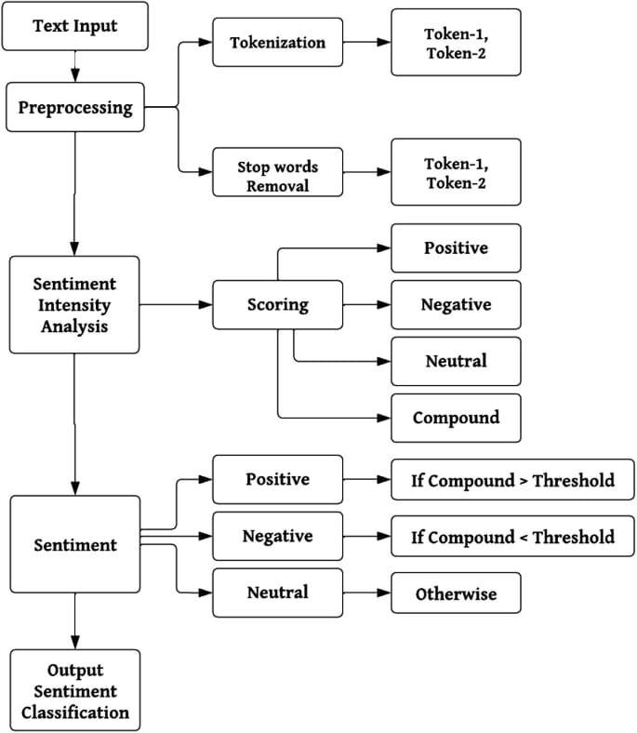

Figure 3.1

1. Input Layer: Customer Reviews Processing
- The system ingests customer reviews from the e-commerce platform.
- Each review is passed through a BERT-based Tokenizer, converting raw text into tokens (numerical representations).
- These tokens are formatted with special tokens like [CLS] (classification token) and [SEP] (separator token) to improve context understanding.

2. Pre-Training Phase: Context Learning
- The model undergoes unsupervised pre-training using two primary objectives:
- Masked Language Modeling (MLM): The model predicts missing words in a sentence, helping it understand word relationships.
- Next Sentence Prediction (NSP): The model learns to determine if one sentence logically follows another, improving contextual understanding.
- This step ensures the model has a deep comprehension of language structure before fine-tuning.

3. Fine-Tuning Phase: Sentiment Training
- The model is fine-tuned using labeled sentiment datasets (positive, neutral, negative).
- Feature extraction techniques help identify keywords related to product quality, fit, and durability.
- Optimization techniques (e.g., Adam Optimizer, Cross-Entropy Loss) are applied to enhance classification accuracy.

4. Model Training: Classification Layer
- The processed tokens are passed to a Transformer-based neural network (BERT model).
- The CLS token is used to summarize the sentiment of the entire review.
- The final classifier layer categorizes the sentiment into three classes:
Positive (Green)
Neutral (Yellow)
Negative (Red)

5. Real-Time Processing & Business Intelligence Integration
- The trained model is deployed as a cloud-based NLP engine (AWS/GCP).
- Sentiment analysis results are stored in the database along with metadata (review ID, timestamp, product category).
- Power BI dashboards dynamically visualize:
Customer sentiment trends
Product-specific insights (e.g., high or low-rated features)
Real-time business recommendations based on sentiment trends.

6. Output & Business Actions
- Insights are delivered to business owners via:
- Sentiment trend analysis
- Product category-wise sentiment breakdown
- Forecasted impact of customer sentiment on future sales
- Business owners can take data-driven actions, such as:
- Adjusting pricing and inventory levels
- Improving product descriptions based on feedback
- Launching targeted marketing campaigns for negatively reviewed products

Diagram Elements:
- Input: Sample customer review → BERT Tokenizer → Tokens
- Pre-Training: MLM + NSP Learning
- Fine-Tuning: Training the model with labeled sentiment data
- Model Training: Transformer-based architecture → Classifier Layer (CLS, SEP tokens)
- Output: Sentiment classification into Positive, Neutral, or Negative
- Business Intelligence: Data sent to Power BI for visualization and decision-making

3.2 Use Case Diagram

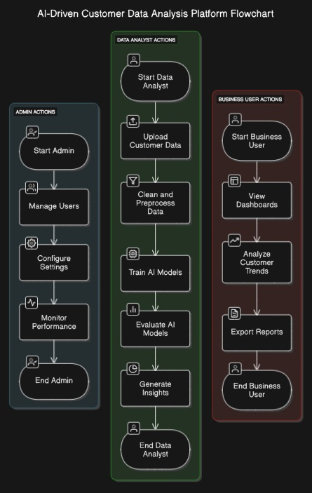

Figure 3.2

Admin Actions (System Management & User Control)

The Admin role focuses on system configuration, user management, and performance monitoring.

Start Admin → The admin logs into the system to oversee operations.

Manage Users → Controls access levels, user registration, and role assignments (Data Analysts, Business Users).

Configure Settings → Sets up AI models, database connections, security protocols, and real-time monitoring configurations.

Monitor Performance → Tracks system efficiency, AI processing speed, data accuracy, and overall platform health.

End Admin → The admin logs out after ensuring the system functions optimally.

2. Data Analyst Actions (AI Processing & Data Insights)

The Data Analyst role is responsible for uploading, cleaning, analyzing data, and training AI models to derive meaningful insights.

Start Data Analyst → The data analyst initiates the data processing pipeline.

Upload Customer Data → Collects structured and unstructured data from multiple sources (e.g., customer reviews, sales transactions, website interactions).

Clean and Preprocess Data → Applies data filtering, missing value imputation, outlier detection, and normalization to ensure high-quality input.

Train AI Models → Implements Natural Language Processing (NLP), Machine Learning (ML), and Deep Learning techniques to:

Perform sentiment analysis on customer feedback.

Extract keywords and categorize product attributes.

Predict future sales trends based on historical data.

Evaluate AI Models → Compares model performance metrics (accuracy, precision, recall, F1-score) and selects the best-performing model.

Generate Insights → Produces actionable insights such as:

Identifying trending products.

Detecting customer dissatisfaction patterns.

Suggesting improvements for marketing and pricing strategies.

End Data Analyst → The data analyst finalizes the AI model evaluation and insights generation.

3. Business User Actions (Dashboard & Strategic Decision-Making)

The Business User role focuses on analyzing AI-generated insights, monitoring sales trends, and making data-driven business decisions.

Start Business User → The business user logs in to access analytics and reports.

View Dashboards → Interacts with Power BI visualizations showcasing:

Sentiment analysis results.

Customer behavior patterns.

Real-time sales performance metrics.

Analyze Customer Trends → Uses AI-generated insights to:

Identify key factors influencing customer satisfaction.

Optimize product pricing, discounts, and stock replenishment.

Plan marketing campaigns based on consumer sentiment.

Export Reports → Downloads reports for stakeholder presentations, internal meetings, and strategic planning.

End Business User → Logs out after reviewing insights and making necessary business decisions.

3.3 Class Diagram

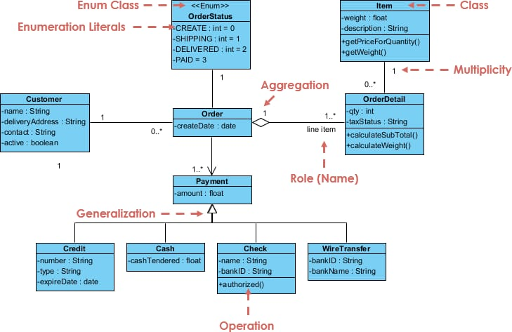

Figure 3.3

Objective

This class diagram represents the key components of an order management system, defining relationships between customers, orders, payments, items, and order details. It includes inheritance, aggregation, enumeration, and multiplicity to model real-world interactions effectively.

Class Components & Description

1. Customer Class

Stores customer details, including personal and delivery information.

Attributes:

name: String – Customer's full name

deliveryAddress: String – Shipping address

contact: String – Phone number or email

active: boolean – Indicates if the customer is active

Example Use Case:A customer places an order using their saved delivery address.

2. Order Class

Represents a purchase order made by a customer.

Attributes:

createDate: date – Date when the order was created

Example Use Case: A customer places an order on a specific date, and the system records it.

3. Payment Class (Parent Class)

Stores payment details for an order.

Attributes:

amount: float – Total amount paid

Example Use Case: A customer completes a payment for their purchase.

4. Payment Subclasses

Represents different payment methods.

Credit: Stores credit card details like number, type, and expiration date.

Cash: Stores cash tendered for the purchase.

Check: Stores check details and includes an authorization method.

WireTransfer: Stores bank ID and bank name for wire transfers.

Example Use Case: A customer pays using a Visa card or a check, and the system processes the payment accordingly.

5. OrderStatus (Enumeration Class)

Defines different statuses an order can have.

Enumeration Literals:

CREATE = 0 – Order is created

SHIPPING = 1 – Order is being shipped

DELIVERED = 2 – Order has been delivered

PAID = 3 – Payment is completed

Example Use Case: An order is updated from "SHIPPING" to "DELIVERED" once received by the customer.

6. OrderDetail Class

Stores specific details of each item in an order.

Attributes:

qty: int – Quantity of the item

taxStatus: String – Tax status

Operations:

calculateSubTotal() – Computes total price

calculateWeight() – Computes total weight

Example Use Case: A customer orders multiple items, and the system calculates the total cost.

7. Item Class

Represents products available for purchase.

Attributes:

weight: float – Product weight

description: String – Product description

Operations:

getPriceForQuantity() – Calculates price based on quantity

getWeight() – Returns total weight

Example Use Case: A customer buys multiple units of an item, and the system calculates the price.

Process Flow

Customer places an order – The system creates an order with an initial status.

Payment processing – The customer selects a payment method.

Order details & item association – The system records item details.

Order status updates – The system updates the order from "CREATE" to "DELIVERED."

Payment confirmation – If paid, the order status is marked as "PAID."

Diagram Representation

Classes: Represented with attributes and operations.

Enumeration Class: Displays predefined order statuses.

Generalization: Uses inheritance for different payment methods.

Aggregation: Represents relationships like orders containing multiple items.

Multiplicity: Defines one-to-many relationships between components.

Business Value

Tracks orders, payments, and statuses efficiently

Supports multiple payment methods

Ensures real-time stock updates

Aggregates data for business insights

Improves customer experience with seamless order tracking

This class diagram provides a structured approach to managing orders, payments, and inventory in an e-commerce system.

3.4 Data Flow Diagram

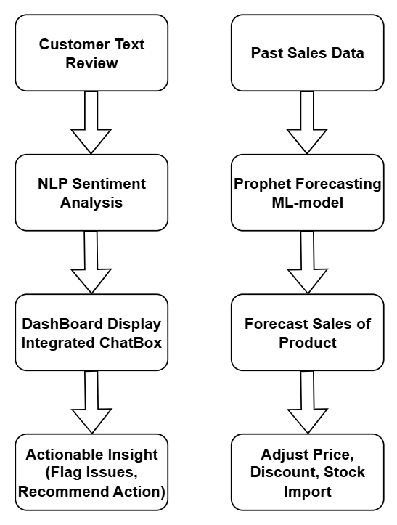

Figure 3.4

Objective

This flow diagram illustrates an AI-driven system that combines Natural Language Processing (NLP) for Sentiment Analysis and Machine Learning (ML) for Sales Forecasting. The system provides actionable insights for product pricing, stock management, and customer engagement.

Left Workflow: Customer Sentiment Analysis

Purpose: Understanding customer feedback to enhance product experience.

Customer Text Review Collection →

Gathers customer feedback from multiple sources (e.g., website, social media, product reviews).

Preprocesses text by removing noise (stopwords, special characters, etc.).

NLP Sentiment Analysis →

Uses AI-based sentiment models (BERT, TextBlob, or SVM) to classify reviews as Positive, Neutral, or Negative.

Extracts keywords to identify trends related to product quality, pricing, and service.

Dashboard Integration & AI Chatbot →

Visualizes real-time sentiment analysis in Power BI.

Provides an AI chatbot for business users to query insights dynamically.

Actionable Business Insights →

Flags critical customer issues (e.g., complaints about fit, material quality).

Recommends actions (e.g., improving specific products, enhancing customer support).

Right Workflow: AI-Driven Sales Forecasting

Purpose: Predicting product demand and optimizing business strategies.

Historical Sales Data Collection →

Extracts past sales data from e-commerce records.

Identifies seasonal trends and demand fluctuations.

Prophet ML-Based Forecasting →

Uses Facebook Prophet Model to predict future sales trends.

Incorporates factors like seasonality, holidays, and past performance.

Predicting Future Sales Performance →

Estimates revenue, demand spikes, and slow-moving products.

Provides a monthly and quarterly forecast.

Business Strategy Optimization →

Price Adjustments → Suggests increasing or decreasing product prices based on demand.

Discount Recommendations → Proposes promotional discounts for slow-moving inventory.

Stock Management → Advises restocking high-demand products to prevent stockouts.

Flowchart Structure Guidelines

Two Parallel Flows – One for NLP-based Sentiment Analysis and another for ML-based Sales Forecasting.

Stepwise Process Blocks – Each major step should be clearly labeled, with arrows guiding the flow.

Decision Points – Business actions (e.g., price adjustment, stock replenishment, product improvements) should be highlighted in bold.

Color Coding –

Blue for Data Collection

Green for AI Processing (NLP & ML)

Orange for Dashboard & Insights

Red for Critical Business Actions

End Result

A comprehensive, AI-powered system that enables e-commerce businesses to make data-driven decisions, enhance customer satisfaction, and optimize sales strategies dynamically.

3.5 Activity Diagram

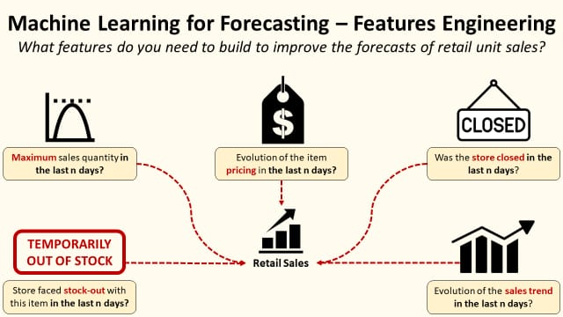

Figure 3.5

Objective

This activity diagram outlines the key processes involved in leveraging machine learning (ML) techniques to improve retail unit sales forecasting through feature engineering. It highlights various factors that influence sales trends, pricing decisions, stock availability, and store operations, ensuring a data-driven approach to retail sales prediction.

This diagram is essential for businesses looking to optimize inventory management, pricing strategies, and demand planning using ML-based forecasting models.

1. Identifying Key Features for Sales Forecasting

To build a robust ML model for retail sales forecasting, the following critical factors must be considered:

A. Maximum Sales Quantity in the Last "n" Days

Analyzes peak sales volume for a given product over a specified period.

Helps identify seasonal demand trends and high-performing products.

Supports businesses in predicting future demand and planning stock replenishment efficiently.

Example: If a product's maximum sales peaked during the last 7 days, the retailer can anticipate high demand and restock accordingly.

B. Evolution of Item Pricing in the Last "n" Days

Tracks price fluctuations and their impact on customer purchasing behavior.

Helps retailers adjust pricing strategies dynamically based on demand trends.

Ensures businesses stay competitive by optimizing discount strategies and promotions.

Example: If a price drop resulted in a spike in sales, it suggests that customers are price-sensitive, and strategic discounts should be applied in future forecasts.

C. Store Stock-Out Status in the Last "n" Days

Identifies if a product was out of stock, leading to potential lost sales.

Helps determine the frequency of stockouts and their impact on revenue.

Supports automated inventory management by predicting when stock levels need replenishment.

Example: If a product was out of stock for multiple days, the ML model can estimate the missed sales opportunity and suggest increasing stock levels in the future.

D. Store Closure in the Last "n" Days

Determines whether the store was closed, affecting sales performance.

Helps in excluding non-operational days from demand forecasting models.

Ensures accurate forecasting by distinguishing sales drops due to store closure rather than reduced customer demand.

Example: If a drop in sales aligns with a store closure period, the ML model should not misinterpret this as a decline in customer interest.

E. Evolution of Sales Trend in the Last "n" Days

Analyzes the overall trend of product sales over time.

Helps distinguish between seasonal trends, growing trends, and declining demand.

Supports businesses in forecasting future sales trajectories and making data-driven decisions.

Example: If sales of a winter jacket increase as temperatures drop, the model will recognize a seasonal trend and adjust inventory levels accordingly for the next season.

2. Activity Flow in the Diagram

Step 1: Data Collection & Feature Extraction

Gather past sales data, pricing details, stock levels, and operational records.

Extract key features including max sales, pricing trends, stock availability, and store status.

Step 2: Data Preprocessing & Cleaning

Remove errors, duplicates, or incomplete records.

Handle missing data for stockouts and store closures.

Normalize pricing data to ensure consistency across different product categories.

Step 3: Machine Learning Model Processing

Feed the cleaned data into ML algorithms such as Prophet, LSTMs, or XGBoost.

Identify patterns in pricing, stock availability, and seasonal demand.

Generate sales forecasts based on extracted features.

Step 4: Business Insights & Decision-Making

If stockouts are frequent → Adjust inventory levels to prevent lost sales.

If price sensitivity is detected → Optimize discount and pricing strategies.

If store closures affect sales → Exclude non-operational periods from forecasting.

If a seasonal trend is identified → Prepare for demand fluctuations in advance.

Diagram Formatting Guidelines

Activity Flow Representation:

Use decision nodes (diamonds) for feature-based conditions.

Represent data extraction, ML processing, and business actions using rectangular activity boxes.

Indicate dependencies using arrows and dashed lines for optional conditions.

Color Scheme:

Red → Highlights critical factors like stock-outs and store closures.

Yellow → Represents sales trend evolution and price fluctuations.

Black → General process elements like data extraction and ML model processing.

Icons & Symbols:

Graph Icon → Represents maximum sales quantity analysis.

Dollar Tag Icon → Represents pricing evolution tracking.

Stock-Out Indicator → Denotes product unavailability.

Closed Sign → Indicates store closure periods.

Trending Sales Graph → Tracks sales trends over time.

Expected Business Value & Impact

Improved demand forecasting accuracy using ML models

Minimized lost sales due to stockouts and store closures

Optimized inventory levels for better supply chain management

Enhanced pricing strategies based on real-time insights

Increased revenue through proactive business decisions

This activity diagram serves as a strategic blueprint for businesses aiming to leverage AI-driven forecasting methods for retail sales optimization.

CHAPTER 4

SYSTEM IMPLEMENTATION

The implementation of this system integrates Artificial Intelligence (AI), Machine Learning (ML), Natural Language Processing (NLP), and Business Intelligence (BI) to automate customer sentiment analysis, sales forecasting, and data visualization. The core objective is to provide real-time insights into customer feedback, predict product demand trends, and assist businesses in making data-driven decisions.

This system leverages various technological components, including:

- Frontend: Built using React.js for an interactive chatbot UI and customer interaction.
- Backend: Developed using Python (Flask/Django) to handle data processing and API communications.
- Machine Learning Models: Implemented for sentiment analysis (using TextBlob, SVM) and time-series forecasting (using LSTM, Prophet).
- Database: Utilizes MySQL/PostgreSQL for structured storage of customer reviews, sales data, and processed analytics.
- Visualization: Power BI is integrated for interactive dashboards displaying real-time metrics.
- Deployment: The system is hosted on AWS/Google Cloud, ensuring scalability and security.
- This system follows a fully automated workflow where new customer data is collected, analyzed, and updated dynamically without manual intervention.

4.1 LIST OF MODULES

To achieve end-to-end automation, the system is divided into seven core modules:

1. Customer Review Collection Module
Captures and stores customer feedback dynamically from the e-commerce website.

2. Real-Time Sentiment Analysis Module
Processes customer reviews using NLP and classifies them into positive, negative, and neutral sentiments.

3. Sales Data Forecasting Module
Utilizes machine learning models to predict future sales trends based on past purchase data.

4. Keyword Extraction & Classification Module
Extracts key phrases from reviews and categorizes them into different product attributes such as quality, fit, pricing, etc.

5. Power BI Visualization Module
Generates real-time dashboards displaying insights from customer reviews, sentiment trends, and sales performance.

6. NLP Chatbot Module
Provides AI-driven responses to user queries based on historical data, customer feedback, and sales trends.

7. Real-Time Data Synchronization Module
Ensures that all updates in customer reviews, sentiment analysis, and forecasting are automatically reflected across the system.

4.2 MODULE DESCRIPTION

1. CUSTOMER REVIEW COLLECTION MODULE
Functionality:
- Captures customer reviews and ratings from product pages in real-time.
- Stores feedback dynamically in an Excel-based dataset.
- Supports automated web scraping for external review sources.
Example Use Case:
- A customer buys running shoes and writes:
- "The cushioning is perfect for running, but the shoe feels slightly heavy."
System Output:
- Review stored in the database
- Keywords extracted: "Cushioning" (Comfort), "Heavy" (Weight)
- Real-time update in Power BI
Technology Used:
- Web Scraping: BeautifulSoup, Selenium
- Data Storage: Pandas, OpenPyXL

2. REAL-TIME SENTIMENT ANALYSIS MODULE

Functionality:
- Uses AI models to analyze review sentiment dynamically.
- Classifies reviews as positive, negative, or neutral.
- Assigns a sentiment score (e.g., +1 for positive, -1 for negative).
Example Use Case:
- Review:
"The delivery was late, but the product quality is excellent!"
System Output:
- Sentiment breakdown:
- Delivery issue → Negative (-1)
- Product quality → Positive (+1)
- Final Sentiment Score: Neutral (0)
- Power BI updates delivery performance graph
Technology Used:
- NLP Libraries: TextBlob, Vader, NLTK
- Machine Learning Algorithm: Support Vector Machine (SVM)

3. SALES DATA FORECASTING MODULE

Functionality:
- Predicts future sales using historical purchase data.
- Identifies patterns in seasonal demand, product popularity, and pricing.
Example Use Case:
- A retailer wants to know how many winter jackets to stock for December.
System Output:
- Forecast: Sales will increase by 40% due to winter demand
- Retailer adjusts inventory accordingly
- Prevents overstocking or shortages
Technology Used:
- Machine Learning Models: LSTM (Long Short-Term Memory)
- Statistical Model: Prophet (for seasonal analysis)

4. KEYWORD EXTRACTION & CLASSIFICATION MODULE

Functionality:
- Extracts important keywords from reviews.
- Classifies keywords into predefined categories (fit, quality, pricing, etc.).
Example Use Case:
- Review:
"The price is a bit high, but the design is fantastic."
System Output:
- Extracted Keywords: "Price" (Pricing), "Design" (Aesthetics)
- Power BI updates pricing concerns dashboard
Technology Used:
- Keyword Extraction: TF-IDF, Named Entity Recognition (NER)
- Classification Algorithm: K-Means Clustering
5. POWER BI VISUALIZATION MODULE

Functionality:
- Generates interactive dashboards for analyzing trends.
- Displays sentiment distribution, sales trends, and keyword frequency.
Example Use Case:
- Dashboard displays a spike in "Late Delivery" complaints → Retailer optimizes logistics
Technology Used:
- Data Visualization Tool: Power BI
- Data Transformation: DAX

6. NLP CHATBOT MODULE

Functionality:
- Provides AI-powered chat-based support.
- Answers queries based on historical sales, customer feedback, and reviews.
Example Use Case:
User asks:
- "Which product has the best durability rating?"
Chatbot Output:
- "Our best-rated durable product is HRX Running Shoes (4.8 stars)"
Technology Used:
- AI Model: LangChain + GPT-4 Turbo
- Frontend: React.js
- Voice Support: Speech-to-Text API

7. REAL-TIME DATA SYNCHRONIZATION MODULE

Functionality:
- Ensures all updates are reflected in databases, AI models, and Power BI.
- Automates the entire workflow without manual intervention.

Example Use Case:
- A new customer review is posted → Sentiment analysis & keyword extraction run automatically → Dashboard updates in real-time
Technology Used:
- Python Automation: Pandas, OpenPyXL
- API Integration: REST APIs

This AI-powered e-commerce analytics system provides a fully automated, intelligent solution for tracking customer sentiment, forecasting sales, and visualizing trends.
By leveraging AI and NLP, businesses can:
- Improve customer experience
- Optimize pricing & inventory
- Increase revenue through better decision-making

CHAPTER 5

CONCLUSION AND FUTURE SCOPE

5.1 CONCLUSION

The implementation of an AI-driven e-commerce analytics system has successfully demonstrated the potential of sentiment analysis, machine learning-based sales forecasting, and real-time chatbot integration in improving customer experience and business decision-making. By leveraging Natural Language Processing (NLP), AI models, and Power BI dashboards, the system provides actionable insights from customer feedback while enabling dynamic sales predictions.

Key Achievements:

Automated Sentiment Analysis: The system efficiently analyzes customer reviews using TextBlob, SVM, and advanced NLP models, categorizing sentiments into positive, neutral, and negative.

Real-time Feedback Processing: A comment box integrated into product pages allows users to submit real-time feedback, dynamically updating sentiment dashboards.

AI-Powered Chatbot: The chatbot, built using LangChain and GPT-4 Turbo, provides users with insights from Excel-based product reviews, sales trends, and customer engagement metrics.

Predictive Analytics: Prophet forecasting enables accurate sales trend analysis, helping businesses optimize pricing strategies, inventory management, and stock replenishment.

Seamless Power BI Integration: Dashboards offer interactive visualizations of customer behavior, review trends, and product performance.

Scalability and Automation: The end-to-end system operates in real-time, reducing the need for manual interventions and enhancing efficiency.

Despite these advancements, certain challenges were encountered, such as data quality issues, language barriers in multilingual reviews, and model optimization for accuracy. Addressing these will further enhance the system’s reliability.

5.2 FUTURE SCOPE

The potential for growth and refinement of this AI-driven analytics platform is vast. Below are several key areas for future enhancement:

1. Enhancing Sentiment Analysis Accuracy

While current models effectively classify sentiment, improvements can be made by incorporating transformer-based models like BERT, RoBERTa, or LLaMA to improve contextual understanding and handle sarcasm, slang, and multilingual text more effectively.

2. Expansion of Multilingual Support

To cater to a global audience, the sentiment analysis and chatbot system can be expanded with multilingual NLP models that process reviews in various languages while maintaining high translation accuracy.

3. Integration of Deep Learning for Forecasting

Currently, sales forecasting is based on the Prophet ML model. Future enhancements may include:

LSTM (Long Short-Term Memory) networks for better sequential prediction.

Hybrid AI models combining deep learning and traditional statistical techniques to improve forecasting accuracy.

4. Advanced AI Chatbot Features

The chatbot can be made more interactive by:

Voice-based interaction using speech recognition and text-to-speech (TTS) models.

Personalized product recommendations based on user preferences and browsing history.

Integration with external APIs for real-time competitor pricing and market trends.

5. Automation in Business Decision-Making

Beyond analyzing data, the system can be upgraded to autonomously adjust prices, stock imports, and marketing strategies based on:

Customer feedback trends.

Competitor pricing data.

Seasonal demand fluctuations.

6. Enhanced Data Security and Privacy

As customer data is being collected and analyzed, stronger encryption methods, GDPR compliance, and AI-driven anomaly detection can be implemented to secure sensitive information.

7. Cloud-Based Scalability and Deployment

Deploying the system on cloud platforms like AWS, Google Cloud, or Azure will enhance:

Scalability for handling a growing number of customer reviews and sales data.

Real-time updates across multiple e-commerce platforms.

Reduced infrastructure costs through serverless computing and auto-scaling mechanisms.

8. Integration with Social Media and Marketplaces

Future versions of the system can scrape and analyze customer reviews from social media platforms, marketplaces (Amazon, Flipkart), and online forums to provide a broader perspective on brand perception.

The project has laid a strong foundation for an intelligent, automated customer insights system that can revolutionize the e-commerce sector. While the initial implementation has met core objectives, continuous innovation in AI, NLP, and cloud computing will unlock new levels of accuracy, automation, and business impact. By integrating advanced AI-driven insights, real-time forecasting, and adaptive business strategies, the platform can become a powerful tool for enhancing customer satisfaction, optimizing sales performance, and driving business growth in a highly competitive market.

REFERENCES

[1] Ruturaj Patil, Shivashankar K, Dr. Shantavva M Porapur, Mr. Shivanand Kagawade,
"The Role of AI-Driven Social Media Marketing in Shaping Consumer Purchasing Behaviour: An Empirical Analysis of Personalization, Predictive Analytics, and Engagement",
First International Conference on Artificial Intelligence: An Emerging Technology in Management (ICAETM 2024)​

[2] Lakshmi Nivas Nalla, Vijay Mallik Reddy, "AI-Driven Big Data Analytics for Enhanced Customer Journeys: A New Paradigm in E-Commerce", International Journal of Advanced Engineering Technologies and Innovations, Volume 01 Issue 02 (2024)

[3] Seyyed Hesamoddin Motevalli, Hamidreza Razavi, "Enhancing Customer Experience and Business Intelligence: The Role of AI-Driven Smart CRM in Modern Enterprises", Journal of Business and Future Economy, Vol. 1, No. 2, Spring 2024

[4] Alma Bici, Narasimha Rao Vajjhala, "Emerging Trends and Themes in AI-Driven Customer Engagement and Relationship Management", Proceedings of the 5th International Conference on the Role of Innovation, Entrepreneurship and Management for Sustainable Development (ICRIEMSD 2024)

[5] Ajiga, David Iyanuoluwa, et al. (2024), “AI-Driven Predictive Analytics in Retail: A Review of Emerging Trends and Customer Engagement Strategies” – International Journal of Management & Entrepreneurship Research

[6] S. Rama Krishna, Ketan Rathor, Dr. Jarabala Ranga, Anil Kumar N, "Artificial Intelligence Integrated with Big Data Analytics for Enhanced Marketing", International Conference on Inventive Computation Technologies (ICICT) 2023

[7] Dr. D. Sivaganesan, Dhruv Aggarwal, Sridhar K, Arunkumar M, "Feature-Based Sentiment Analysis for Product Reviews", International Journal of Engineering Research & Technology (IJERT), Vol. 11 Issue 06, June 2022

[8] Ashwini Patil, Shiwani Gupta, "A Review on Sentiment Analysis Approaches",
Published in ResearchGate ICWCCV, March 2021

[9] Xing Fang, Justin Zhan, "Sentiment Analysis Using Product Review Data", Journal of Big Data, 2015

[10] Walaa Medhat, Ahmed Hassan, Hoda Korashy, "Sentiment Analysis Algorithms and Applications: A Survey", Ain Shams Engineering Journal, Elsevier, 2014​

[11] Eduard Hovy, Soo-Min Kim, "Determining the Sentiment of Opinions",
Presented at the International Conference on Computational Linguistics (COLING), 2004

SCREENSHOTS

1.Sentiment Analysis/Category Classification

Product Review Dataset
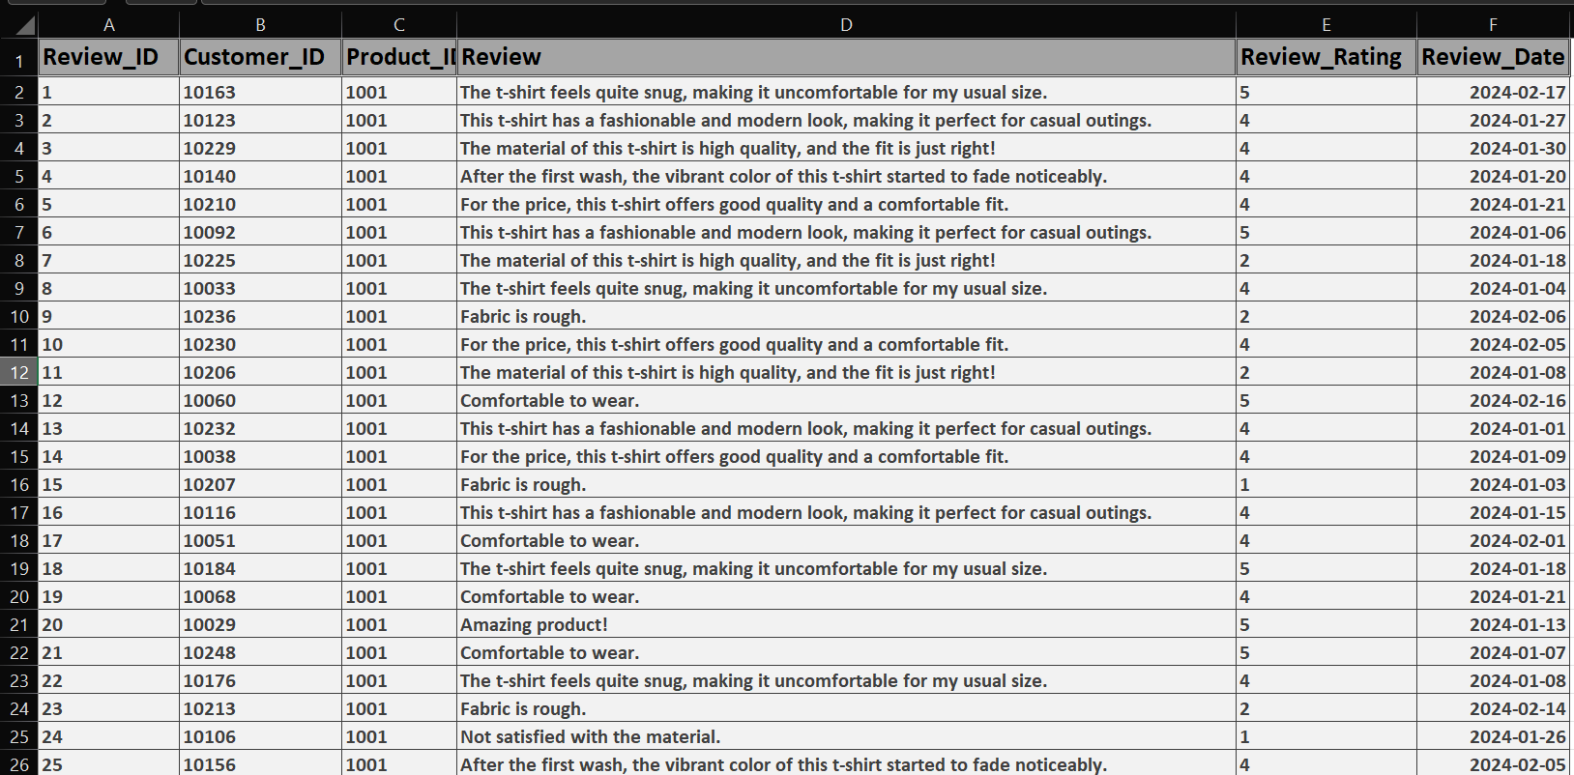
Review Sentiment Dataset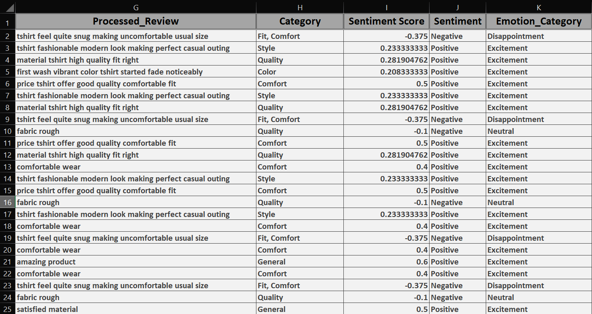
2.Review Issue Alert
Monthly Products Review Dataset
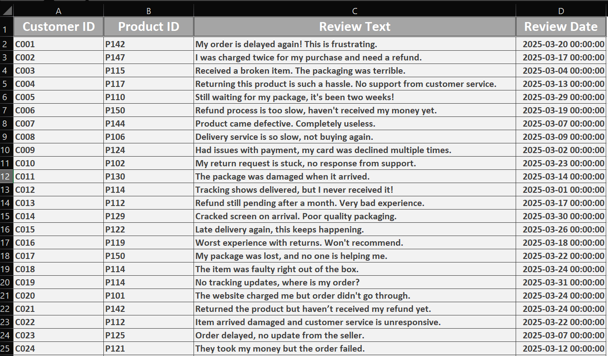
Monthly Notification Alert
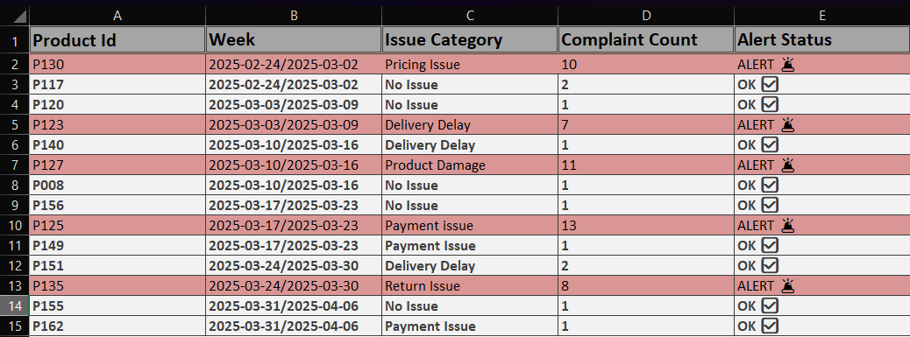
3.Forecast Sales/Stock/price/Discount/Revenue
Past Three Years Sales/Stock/price/Revenue Dataset
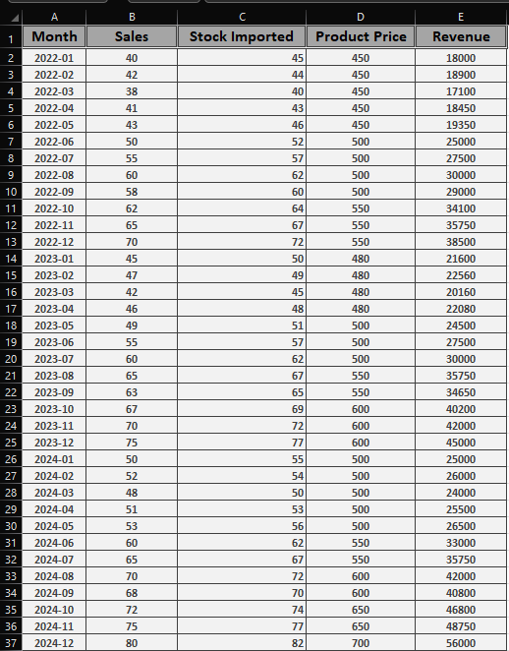
Forecast Sales/Stock/price/Revenue Dataset
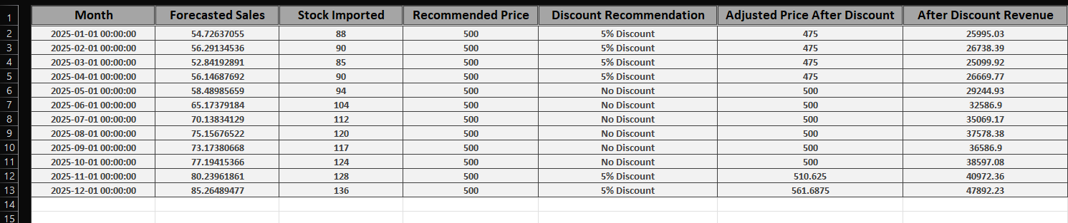

4.Project Display
Product front page
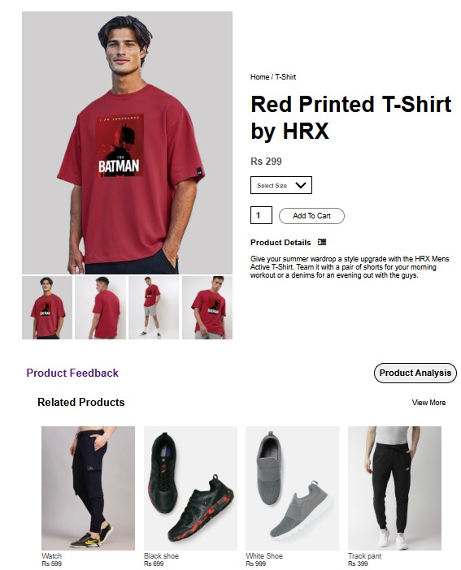
Product Feedback Section
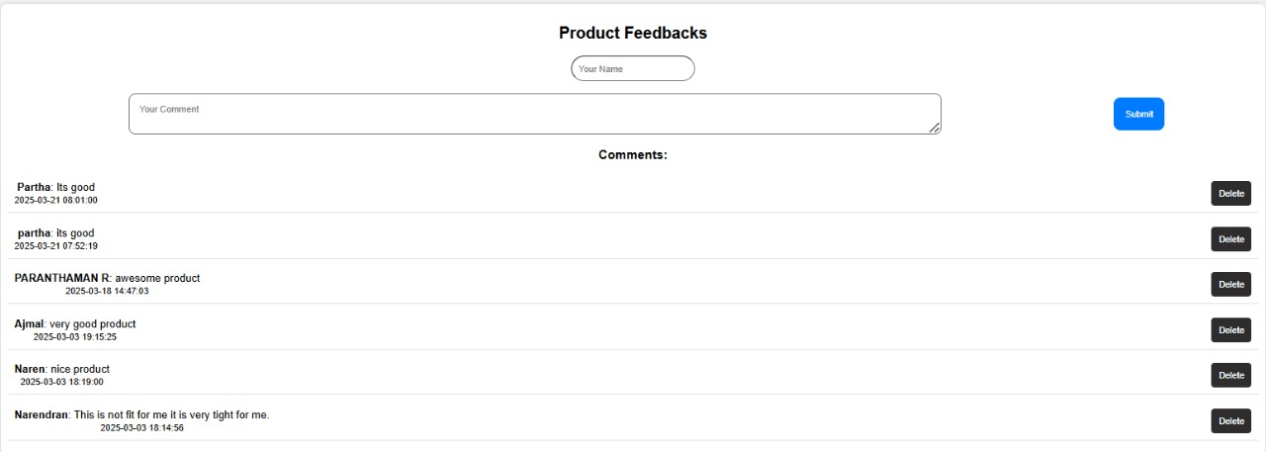

Product Dashboard
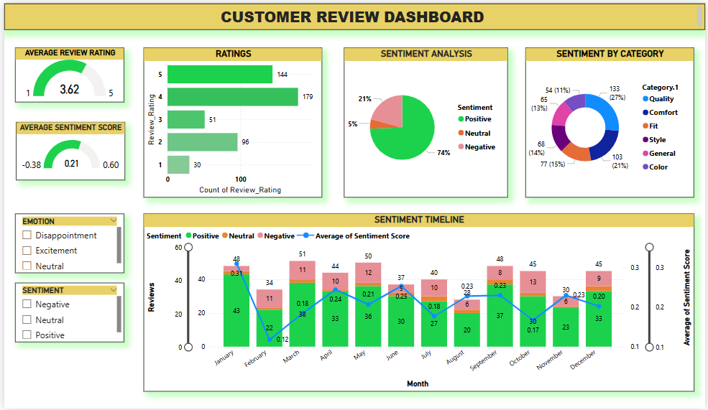
Insight with Analysis Chatbox
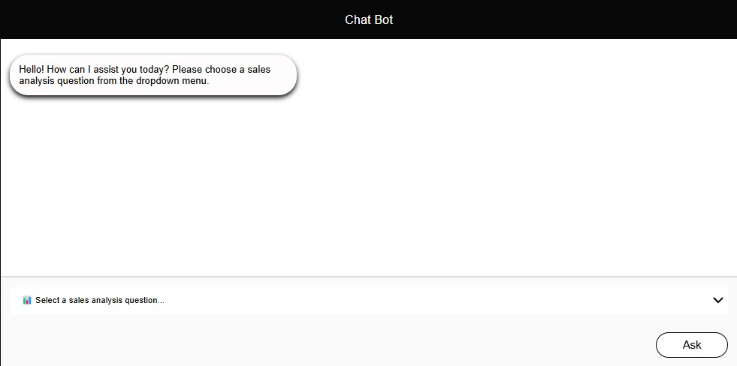

Product Issue Alert System
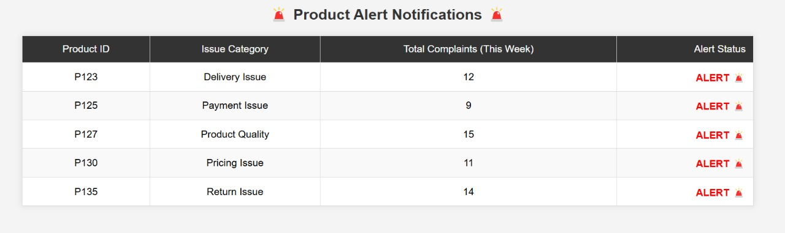
Forecast sales/Stock/Discount/Price/Revenue


